
SCHOOL OF COMPUTING
Department of Artificial Intelligence and Machine Learning
ONLINE SHOPPING SYSTEM
A Cornerstone Project Report
BATCH-01
Submitted in partial fulfillment of the requirements for the award of the degree of
BACHELOR OF TECHNOLOGY
in
ARTIFICIAL INTELLIGENCE AND MACHINE LEARNING
Submitted by
K.MADHULIKA (25B11AI552)
K.JOSHITHA (25B11AI430)
S.RHODA REDDY (25B11AI493)
A.SRI VICTORIA (25B11AIB42)
S.V.D.MOUNIKA (26B21AI103)
Under the guidance of
Dr. P. Kishorekumar, PhD.
Associate Professor, Department of AIML
ADITYA UNIVERSITY, SURAMPALEM
Academic Year: 2026 - 2027

SCHOOL OF COMPUTING
Department of Artificial Intelligence and Machine Learning
CERTIFICATE
This is to certify that the Cornerstone project work entitled "ONLINE SHOPPING SYSTEM" is submitted by
K.MADHULIKA (25B11AI552)
K.JOSHITHA (25B11AI430)
S.RHODA REDDY (25B11AI493)
A.SRI VICTORIA (25B11AIB42)
S.V.D.MOUNIKA (26B21AI103)

In partial fulfillment of the requirements for the award of the B.Tech. degree in Artificial Intelligence and Machine Learning for the academic year 2026-2027.

Project Guide  Dr. P. Kishorekumar, PhD.  Associate Professor, Department of AIML | Head of the Department:  Dr. Kovvuri N Bhargavi  Associate Professor & HOD

DECLARATION
We hereby declare that the Cornerstone project entitled "ONLINE SHOPPING SYSTEM" is original and is submitted to ADITYA UNIVERSITY, Surampalem, in partial fulfillment of the requirements for the award of the B.Tech. Degree in Artificial Intelligence and Machine Learning. We further declare that this project work has not been submitted, either in full or in part, for the award of any degree in this or any other institution. We also confirm that this work complies with the Institutional Academic Integrity and AI Usage Policy.
Place: Surampalem
Date:
By
K.MADHULIKA (25B11AI552)
K.JOSHITHA (25B11AI430)
S.RHODA REDDY (25B11AI493)
A.SRI VICTORIA (25B11AIB42)
S.V.D.MOUNIKA (26B21AI103)

ACKNOWLEDGEMENT
It is with immense pleasure that we express our sincere gratitude to our Cornerstone Project Guide, Dr. P. Kishorekumar, PhD. Associate Professor, Department of AIML, who has guided us throughout the project. His valuable support, encouragement, and guidance have greatly contributed to the successful completion of this work.
We would like to thank our Deputy Heads of the Department, Dr. B. Manikyala Rao, Associate Professor, Dr. R. Suneetha, Assistant Professor and Dr. D. Veeraswamy, Assistant Professor for their support and valuable suggestions.
Our deepest thanks to our Head of the Department Dr. K. Naga Bhargavi, Associate Professor & HOD, for her inspiration and for providing all the necessary facilities and resources required for this project.
We also extend our sincere thanks to Dr. M.V. Rajesh, Associate Dean, School of Computing for their encouragement and support during the course of our project.
We would like to express our sincere gratitude to Dr. G. Suresh, Registrar, Dr. A. Ramesh, Pro Vice-Chancellor (Engineering & Sciences), Dr. S. Rama Sree, Pro Vice-Chancellor (Academics), Dr. M.B. Srinivas, Vice-Chancellor, Dr. M. Sreenivasa Reddy, Deputy Pro Chancellor and Management, Aditya University for providing excellent infrastructure and state-of-the-art laboratories.
Finally, we would like to thank the faculty members, lab technicians, non-teaching staff, and our friends who have directly or indirectly supported us in completing this Cornerstone project successfully.
BY K.MADHULIKA (25B11AI552)
K.JOSHITHA (25B11AI430)
S.RHODA REDDY (25B11AI493)
A.SRI VICTORIA (25B11AIB42)
S.V.D.MOUNIKA (26B21AI103)

TABLE OF CONTENTS

1. Cover Page 1
2. Certificate 2
3. Declaration 3
4. Acknowledgement 4
5. Abstract 6
6. List of Figures / List of Tables / Acronyms 7
7. Introduction 9
8. System Analysis 11
9. Database Design 13
10. ER Diagram 15
11. Relational Schema 17
12. Table Design 18
13. Normalization 22
14. SQL Implementation 24
15. SQL Queries & Screenshots 28
16. Conclusion & Future Enhancements 39
17. References 41

ABSTRACT
This project presents the design and implementation of a database system for an Online Shopping System, aimed at replacing fragmented manual data keeping with a centralized relational framework. The database architecture systematically structures customer profiles, seller accounts, product catalogs, shopping carts, order histories, payment transactions, shipping logistics, and user reviews.
To ensure optimal performance and eliminate data anomalies, the database schema is structured across 10 core entities: CUSTOMER, PRODUCT, CATEGORY, ORDER, PAYMENT, DELIVERY, ORDER_ITEM, CART, REVIEW, and SELLER. The database applies normalization techniques up to Third Normal Form (3NF) to eliminate repeating groups, partial dependencies, and transitive dependencies, preserving relational integrity across all tables.
Complete SQL implementations are provided, encompassing Data Definition Language (DDL) statements for table creation with constraints, Data Manipulation Language (DML) scripts for record maintenance, and complex Data Query Language (DQL) operations—including relational joins, grouped aggregations, correlated subqueries, database views, and automated triggers. The resulting system minimizes data redundancy, maintains data consistency, and provides a scalable foundation for e-commerce platforms.

LIST OF FIGURES
Figure 1. ER Diagram of the Online Shopping System

LIST OF TABLES
Table 1. Major Database Entities
Table 2. Entity Relationships and Cardinality
Table 3. Relational Schema Summary
Table 4. Customer Table Structure
Table 5. Product Table Structure
Table 6. Category Table Structure
Table 7. Order Table Structure
Table 8. Payment Table Structure
Table 9. Delivery Table Structure
Table 10. Order_Item Table Structure
Table 11. Cart Table Structure
Table 12. Review Table Structure
Table 13. Seller Table Structure
Table 14. Keys and Constraints Summary

ACRONYMS
- DBMS – Database Management System
- ER – Entity Relationship
- SQL – Structured Query Language
- DDL – Data Definition Language
- DML – Data Manipulation Language
- DQL – Data Query Language
- DCL – Data Control Language
- TCL – Transaction Control Language
- PK – Primary Key
- FK – Foreign Key
- 1NF – First Normal Form
- 2NF – Second Normal Form
- 3NF – Third Normal Form

1. INTRODUCTION

1.1 Brief Information about the Project

Online shopping allows customers to purchase products through a digital platform. The system stores customer, product, order, payment and delivery information in a structured database. The project focuses on designing the database structure for an Online Shopping System, including entities, attributes, keys, relationships and an ER model.

1.2 Motivation and Contribution of the Project

The rapid growth of online shopping has made it important to manage large amounts of customer, product, order, payment, and delivery information efficiently. Traditional methods of maintaining such information can lead to data duplication, difficulty in searching records, and errors in updating information. This project is motivated by the need for a centralized and well-structured database that can organize online shopping information in a reliable manner.
- Organizing shopping information in a centralized relational database.
- Reducing duplicate and inconsistent product and customer information.
- Maintaining relationships using Primary Keys and Foreign Keys.
- Supporting efficient retrieval of product, order and customer information.
- Providing a database foundation for online shopping activities.

1.3 Objectives of the Project
- Identify the major entities involved in hospital management.
- Identify suitable attributes for each entity.
- Establish relationships between the identified entities.
- Design an Entity–Relationship (ER) diagram.
- Convert the ER model into a relational database schema.
- Identify suitable Primary Keys and Foreign Keys.
- Reduce data duplication and maintain data consistency.
- Provide an organized database structure for efficient hospital record management.

1.4 Scope of the Project
The scope of the Online Shopping System is to design and develop a structured relational database for efficiently managing the major activities involved in an online shopping platform. The database stores customer details, product information, prices, stock availability, product categories, customer orders, order items, payment details, delivery information, shopping cart records, customer reviews, ratings, and seller details. The system establishes relationships between these entities using Primary Keys and Foreign Keys to maintain data integrity and consistency. The database design helps reduce data duplication, improve information organization, and provide faster access to shopping-related records. Overall, the project demonstrates the practical application of DBMS concepts such as entities, attributes, relationships, keys, normalization, constraints, and SQL in developing a real-world Online Shopping System.

2. SYSTEM ANALYSIS

2.1 Existing System
- Shopping information may be maintained in separate files or systems.
- Product and customer records can become duplicated.
- Searching for order and product information may take more time.
- Updating related information manually can cause inconsistency.
- Generating consolidated shopping information can be difficult.

2.2 Proposed System

The proposed Online Shopping System uses a relational database to connect shopping records through entities, relationships, Primary Keys and Foreign Keys. It organizes online shopping information like customer, product, category, order, payment and delivery information into related tables and uses primary keys, foreign keys, uniqueness rules, NOT NULL conditions, and CHECK constraints to enforce valid data.
- Customer account and information management.
- Product details and price management.
- Category-based product organization.
- Order and order-item management.
- Payment information management.
- Delivery tracking information.
- Billing and payment-status management.
- Cart and product review support.
- Seller information management.

2.3 Functional Requirements
Module | Functional Requirement
Customer Management | Store and manage customer details and accounts.
Product Management | Store product names, prices and stock details.
Category Management | Organize products into categories.
Order Management | Maintain customer orders and ordered products.
Payment Management | Maintain payment method and payment status.
Delivery Management | Maintain delivery date and delivery status.
Cart Management | Maintain customer cart information.
Review Management | Store customer ratings and comments for products.
Seller Management | Maintain seller details.

2.4 Non-Functional Requirements
- Performance – information should be retrieved efficiently.
- Integrity – relationships should be maintained using keys and constraints.
- Security – customer and payment information should be protected.
- Usability – database structure should be understandable.
- Reliability – shopping records should remain consistent.
- Scalability –the database should support increasing products, customers and orders.
2.5 Requirements Specification
Category | Requirement
Hardware | Intel i3 or above; 4 GB RAM minimum; adequate storage; standard display and keyboard/mouse.
Operating System | Windows 10/11 or an equivalent supported platform.
Database | MySQL Relational Database Management System.
3. DATABASE DESIGN

3.1 Major Entities
Ten major entities have been identified for the proposed Online Shopping System, as summarised in Table 1.
Table 1: Major Database Entities
Entity | Description
CUSTOMER | Stores customer details and contact information.
PRODUCT | Stores product names, prices and stock.
CATEGORY | Stores product category information.
ORDER | Stores customer order details.
PAYMENT | Stores payment method and status.
DELIVERY | Stores delivery date and status.
ORDER_ITEM | Connects orders with products and stores quantity and price.
CART | Stores customer cart information.
REVIEW | Stores customer ratings and comments for products.
SELLER | Stores seller details.

3.2 ER Model
The ER model represents the major entities of the Online Shopping System and the relationships between them. CUSTOMER and ORDER form the core transaction relationship, while PRODUCT and CATEGORY organize product information. ORDER_ITEM connects orders with products and represents the many-to-many relationship between them. PAYMENT and DELIVERY are linked to ORDER, while CART and REVIEW support customer shopping activities. Primary Keys (PK) and Foreign Keys (FK) are used to identify records and maintain the relationships between related entities.

3.3 Relationships and Cardinality
Table 2: Entity Relationships and Cardinality
Relationship | Cardinality | Meaning
CUSTOMER - ORDER | 1 : M | . One customer can place many orders, but each order belongs to one customer.
ORDER - PRODUCT | M : M | One order can contain many products, and one product can be included in many orders.
PRODUCT - CATEGORY | M : 1 | Many products can belong to one category.
ORDER - PAYMENT | 1 : 1 | Each order is associated with one payment record.
ORDER - DELIVERY | 1 : 1 | Each order is associated with one delivery record.
CUSTOMER - CART | 1 : 1 | Each customer has a shopping cart associated with their account.
CART - PRODUCT | M : M | A cart can contain multiple products, and a product can appear in multiple customers' carts.
CUSTOMER - REVIEW | 1 : M | One customer can write multiple reviews.
PRODUCT - REVIEW | 1 : M | One product can receive multiple reviews from customers.
SELLER - PRODUCT | 1 : M | One seller can sell multiple products, while each product is associated with a seller.
ORDER – ORDER_ITEM | 1 : M | One order can have multiple order items.
PRODUCT – ORDER_ITEM | 1 : M | One product can appear in multiple order items.

4. ER DIAGRAM
Figure 1: ER Diagram of the Online Shopping System( SOFTWARE BASED)
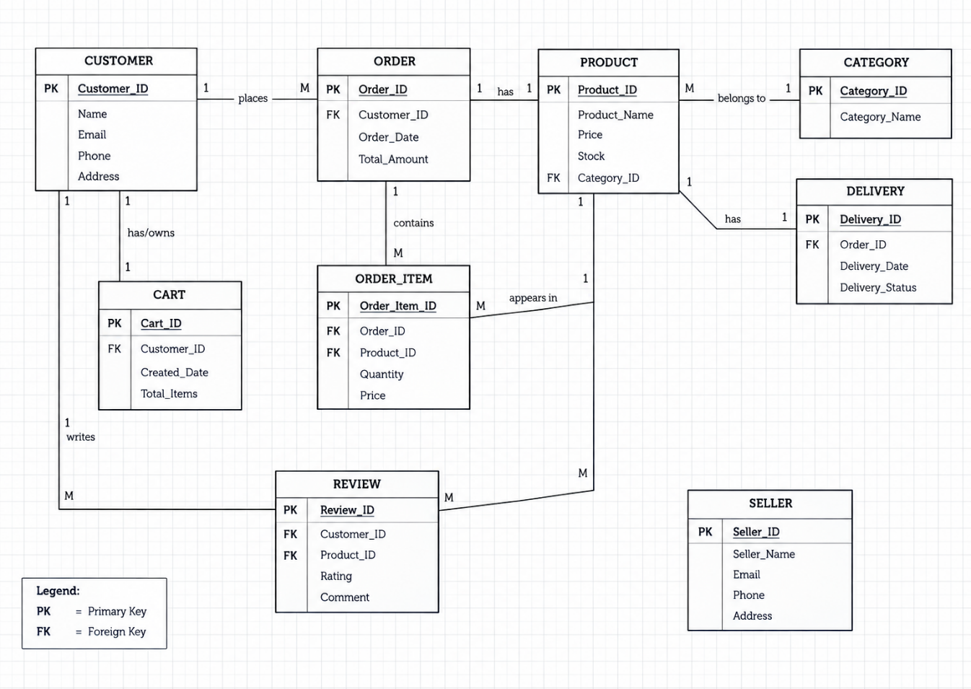
The ER diagram shows the ten entities of the Online Shopping System and the one-to-many relationships between them. Primary Keys (PK) and Foreign Keys (FK) are marked within each entity box, consistent with the relational schema and the SQL implementation presented in the following sections.

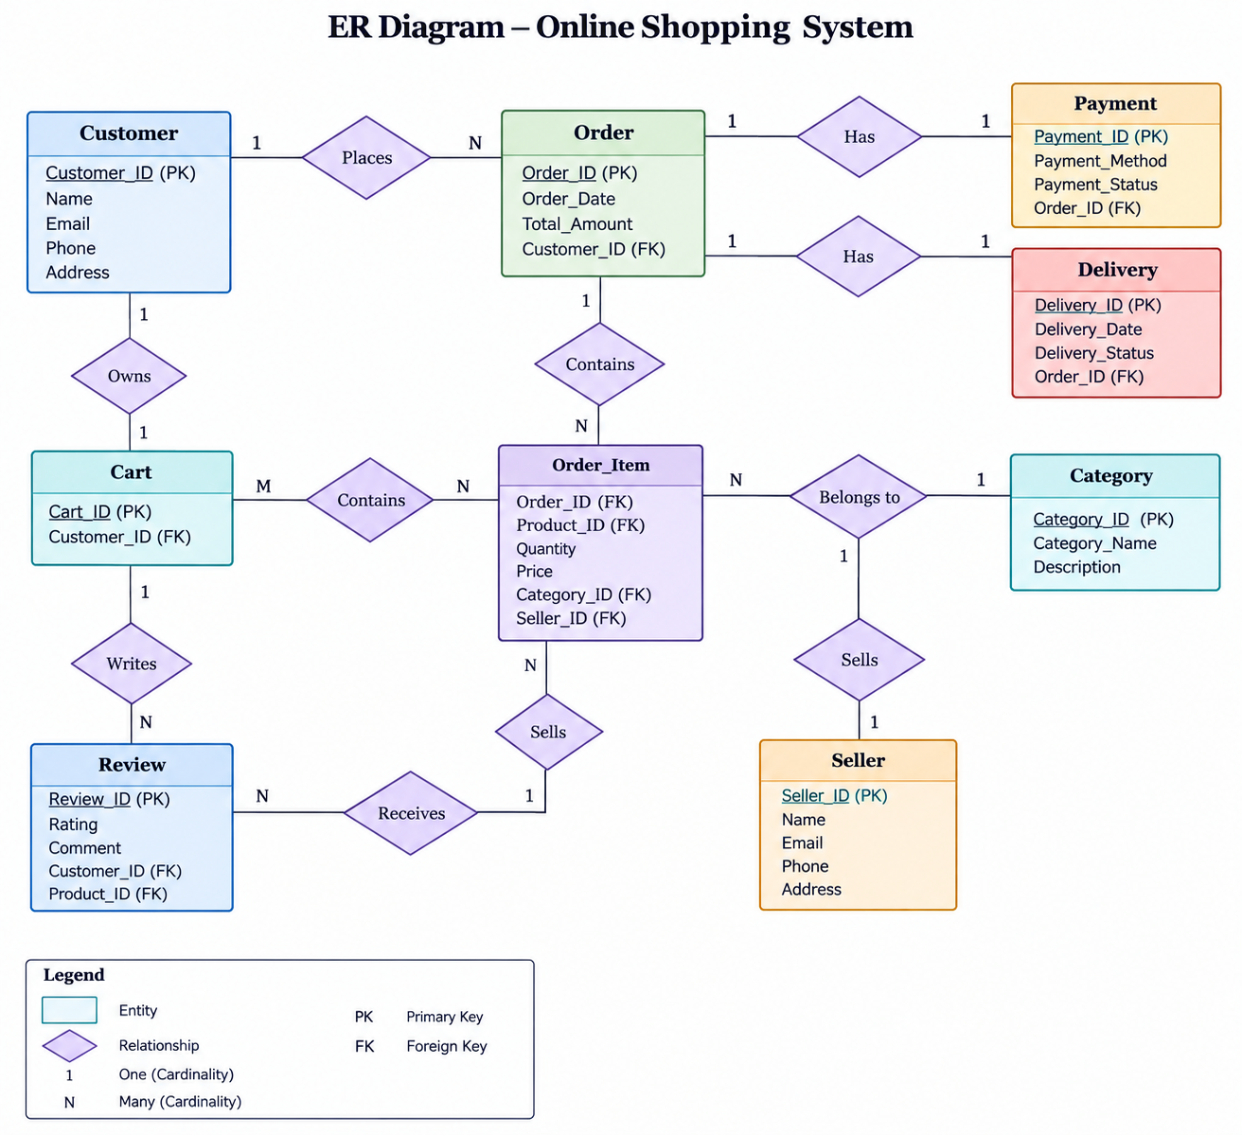
Figure 2: ER Diagram of the Online Shopping System (MANUAL)

5. RELATIONAL SCHEMA
The relational schema below follows the table-creation order used in the SQL implementation, so that every Foreign Key already has a valid parent table defined before it.
Table 3: Relational Schema Summary
Relation | Relational Schema | Keys
CUSTOMER | Customer(Customer_ID, Name, Email, Phone, Address) | PK: Customer_ID
PRODUCT | Product(Product_ID, Product_Name, Price, Stock, Category_ID) | PK: Product_ID ; FK: Category_ID
CATEGORY | Category(Category_ID, Category_Name) | PK: Category_ID
ORDER | Order(Order_ID, Customer_ID, Order_Date, Total_Amount | PK: Room_ID; FK: Department_ID
PAYMENT | Payment(Payment_ID, Order_ID, Payment_Method, Payment_Status) | PK: Doctor_ID; FK: Department_ID
DELIVERY | Delivery(Delivery_ID, Order_ID, Delivery_Date, Delivery_Status) | PK: Appointment_ID; FK: Patient_ID, Doctor_ID
ORDER_ITEM | Order_Item(Order_Item_ID, Order_ID, Product_ID, Quantity, Price) | PK: Admission_ID; FK: Patient_ID, Room_ID
CART | Cart(Cart_ID, Customer_ID, Created_Date, Total_Items) | PK: Treatment_ID; FK: Patient_ID, Doctor_ID
REVIEW | Review(Review_ID, Customer_ID, Product_ID, Rating, Comment) | PK: Prescription_ID; FK: Patient_ID, Doctor_ID, Medicine_ID
SELLER | Seller(Seller_ID, Seller_Name, Email, Phone, Address) | PK: Bill_ID; FK: Patient_ID, Admission_ID

The Product relation references Category; Order references Customer; Payment and Delivery reference Order; Order_Item references Order and Product; Cart references Customer; and Review references Customer and Product.

6. TABLE DESIGN

6.1 CustomerTable
Table 4:Customer Table Structure
Attribute | Data Type | Constraint | Description
Customer_ID | INT | PK | Unique customer identifier
Name | VARCHAR(100) | NOT NULL | Customer name
Email | VARCHAR(100) | NOT NULL | Customer email
Phone | VARCHAR(15) | NOT NULL | Contact number
Address | VARCHAR(255) | NOT NULL | Customer address

6.2 Product Table
Table 5: Product Table Structure
Attribute | Data Type | Constraint | Description
Product_ID | INT | PK | Unique product identifier
Product_Name | VARCHAR(100) | NOT NULL | Product name
Price | DECIMAL(10,2) | NOT NULL | Product price
Stock | INT | NOT NULL | Available stock
Category_ID | INT | FK | References Category

6.3 Category Table
Table 6: Category Table Structure
Attribute | Data Type | Constraint | Description
Category_ID | INT | PK | Unique category identifier
Category_Name | VARCHAR(100) | NOT NULL | Category name

6.4 Order Table
Table 7: Order Table Structure
Attribute | Data Type | Constraint | Description
Order_ID | INT | PK | Unique order identifier
Customer_ID | INT | FK | References Customer
Order_Date | DATE | NOT NULL | Order date
Total_Amount | DECIMAL(10,2) | NOT NULL | Total order amount

6.5 Payment Table
Table 8: Payment Table Structure
Attribute | Data Type | Constraint | Description
Payment_ID | INT | PK | Unique payment identifier
Order_ID | INT | FK | References Order
Payment_Method | VARCHAR(50) | NOT NULL | Payment method
Payment_Status | VARCHAR(30) | NOT NULL | Payment status

6.6 Delivery Table
Table 9: Delivery Table Structure
Attribute | Data Type | Constraint | Description
Delivery_ID | INT | PK | Unique delivery identifier
Order_ID | INT | FK | References Order
Delivery_Date | DATE | NOT NULL | Delivery date
Delivery_Status | VARCHAR(30) | NOT NULL | Delivery status
6.7 Order_Item Table
Table 10: Order_Item Table Structure
Attribute | Data Type | Constraint | Description
Order_Item_ID | INT | PK | Unique order-item identifier
Order_ID | INT | FK | References Order
Product_ID | INT | FK | References Product
Quantity | INT | NOT NULL | Quantity ordered
Price | DECIMAL(10,2) | NOT NULL | Product price in order

6.8 Cart Table
Table 11: Cart Table Structure
Attribute | Data Type | Constraint | Description
Cart_ID | INT | PK | Unique cart identifier
Customer_ID | INT | FK | References Customer
Created_Date | DATE | NOT NULL | Cart creation date
Total_Items | INT | NOT NULL | Number of items

6.9 Review Table
Table 12: Review Table Structure
Attribute | Data Type | Constraint | Description
Review_ID | INT | PK | Unique review identifier
Customer_ID | INT | FK | References Customer
Product_ID | INT | FK | References Product
Rating | INT | NOT NULL | Product rating
Comment | VARCHAR(255) | - | Customer comment

6.10 Seller Table
Table 13: Seller Table Structure
Attribute | Data Type | Constraint | Description
Seller_ID | INT | PK | Unique seller identifier
Seller_Name | VARCHAR(100) | NOT NULL | Seller name
Email | VARCHAR(100) | NOT NULL | Seller email
Phone | VARCHAR(15) | NOT NULL | Seller contact
Address | VARCHAR(255) | NOT NULL | Seller address

6.11 Keys and Constraints
Table 14: Keys and Constraints Summary
Constraint Type | Applied To / Purpose
Primary Key | Customer_ID, Product_ID, Category_ID, Order_ID, Payment_ID, Delivery_ID, Order_Item_ID, Cart_ID, Review_ID, Seller_ID
Foreign Key | Product.Category_ID; Order.Customer_ID; Payment.Order_ID; Delivery.Order_ID; Order_Item.Order_ID, Product_ID; Cart.Customer_ID; Review.Customer_ID, Product_ID
NOT NULL | Required attributes such as names, identifiers, dates and status values
VALIDATION | Values such as Price, Stock, Quantity and Rating can be validated

7. NORMALIZATION
Normalization organizes data into related tables to reduce redundancy and avoid update anomalies. The Online Shopping System can be structured through First Normal Form (1NF), Second Normal Form (2NF), and Third Normal Form (3NF).

7.1 Unnormalized Form (UNF)

A single shopping record could contain customer details, product details, category information, order information, payment information and multiple product entries. Repeating product and order-item information in the same record would create redundancy and make updates difficult

7.2 First Normal Form (1NF)
In 1NF, attributes contain atomic values and repeating groups are removed. Individual products in an order are stored as separate Order_Item records rather than as a list inside the Order table.

7.3 Second Normal Form (2NF)

In 2NF, attributes that depend only on part of a composite key are separated. Product details depend on Product_ID, customer details depend on Customer_ID, and order-specific details depend on Order_ID. Separate tables avoid unnecessary repetition.

7.4 Third Normal Form (3NF)
In 3NF, transitive dependencies are removed. Category information is stored in Category rather than repeated for every product reference, while customer, product, payment and delivery information are maintained in their respective relations. This results in a more organized database with reduced redundancy.

Relation | Reason for Separation
Category | Stores category information once instead of repeating category names for every product.
Customer | Stores customer-specific attributes independently of orders.
Relation | Reason for Separation
Product | Stores product-specific attributes and a Category_ID reference.
Order | Stores order-specific details and the customer reference.
Order_Item | Stores individual products, quantities and prices within orders.
Payment | Stores payment-specific details linked to an order.
Delivery | Stores delivery-specific details linked to an order.
Cart | Stores customer cart information separately.
Review | Stores product review details linked to customer and product.
Seller | Stores seller-specific details independently.

8. SQL IMPLEMENTATION

The Online Shopping System database is implemented using SQL by creating tables for Customer, Product, Category, Orders, Payment, Delivery, Order_Item, Cart, Review and Seller. Tables are created in an order that satisfies Foreign Key dependencies and maintains referential integrity. Primary Keys are used to uniquely identify records, while Foreign Keys establish relationships between related tables.

The SQL implementation includes Data Definition Language (DDL) for creating the database and tables, Data Manipulation Language (DML) for inserting, updating and deleting records, and Data Query Language (DQL) for retrieving information from the database.

8.1 DDL – Data Definition Language

CREATE DATABASE online_shopping_db;
USE online_shopping_db;
-- 1. CATEGORY
CREATE TABLE CATEGORY (
Category_ID INT PRIMARY KEY AUTO_INCREMENT,
Category_Name VARCHAR(100) NOT NULL
);
-- 2. CUSTOMER
CREATE TABLE CUSTOMER (
Customer_ID INT PRIMARY KEY AUTO_INCREMENT,
Name VARCHAR(100) NOT NULL,
Email VARCHAR(100) NOT NULL,
Phone VARCHAR(15) NOT NULL,
Address VARCHAR(255) NOT NULL
);
-- 3. PRODUCT
CREATE TABLE PRODUCT (
Product_ID INT PRIMARY KEY AUTO_INCREMENT,
Product_Name VARCHAR(100) NOT NULL,
Price DECIMAL(10,2) NOT NULL,
Stock INT NOT NULL,
Category_ID INT,

FOREIGN KEY (Category_ID)
REFERENCES Category(Category_ID)
);
-- 4. ORDER
CREATE TABLE Orders (
Order_ID INT PRIMARY KEY AUTO_INCREMENT,
Customer_ID INT NOT NULL,
Order_Date DATE NOT NULL,
Total_Amount DECIMAL(10,2) NOT NULL,

FOREIGN KEY (Customer_ID)
REFERENCES Customer(Customer_ID)
);
-- 5. PAYMENT
CREATE TABLE PAYMENT (
Payment_ID INT PRIMARY KEY AUTO_INCREMENT,
Order_ID INT NOT NULL,
Payment_Method VARCHAR(50) NOT NULL,
Payment_Status VARCHAR(30) NOT NULL,

FOREIGN KEY (Order_ID)
REFERENCES Orders(Order_ID)
);
-- 6. DELIVERY
CREATE TABLE DELIVERY (
Delivery_ID INT PRIMARY KEY AUTO_INCREMENT,
Order_ID INT NOT NULL,
Delivery_Date DATE NOT NULL,
Delivery_Status VARCHAR(30) NOT NULL,

FOREIGN KEY (Order_ID)
REFERENCES Orders(Order_ID)
);
-- 7. ORDER_ITEM
CREATE TABLE Order_Item (
Order_Item_ID INT PRIMARY KEY AUTO_INCREMENT,
Order_ID INT NOT NULL,
Product_ID INT NOT NULL,
Quantity INT NOT NULL,
Price DECIMAL(10,2) NOT NULL,

FOREIGN KEY (Order_ID)
REFERENCES Orders(Order_ID),

FOREIGN KEY (Product_ID)
REFERENCES Product(Product_ID)
);
-- 8. CART
CREATE TABLE Cart (
Cart_ID INT PRIMARY KEY AUTO_INCREMENT,
Customer_ID INT NOT NULL,
Created_Date DATE NOT NULL,
Total_Items INT NOT NULL,

FOREIGN KEY (Customer_ID)
REFERENCES Customer(Customer_ID)
);
-- 9. REVIEW
CREATE TABLE Review (
Review_ID INT PRIMARY KEY AUTO_INCREMENT,
Customer_ID INT NOT NULL,
Product_ID INT NOT NULL,
Rating INT NOT NULL,
Comment VARCHAR(255),

FOREIGN KEY (Customer_ID)
REFERENCES Customer(Customer_ID),

FOREIGN KEY (Product_ID)
REFERENCES Product(Product_ID)
);
-- 10. SELLER
CREATE TABLE Seller (
Seller_ID INT PRIMARY KEY AUTO_INCREMENT,
Seller_Name VARCHAR(100) NOT NULL,
Email VARCHAR(100) NOT NULL,
Phone VARCHAR(15) NOT NULL,
Address VARCHAR(255) NOT NULL
);

8.2 DML – Data Manipulation Language

INSERT, UPDATE and DELETE statements can be used to add products and customers, update stock or payment status, and remove or modify records when required.
INSERT INTO Category (Category_Name)
VALUES ('Electronics');

INSERT INTO Customer (Name, Email, Phone, Address)
VALUES ('Rahul Kumar', 'rahul@gmail.com', '9876543210', 'Hyderabad');

INSERT INTO Product (Product_Name, Price, Stock, Category_ID)
VALUES ('Wireless Headphones', 1499.00, 25, 1);

INSERT INTO Orders (Customer_ID, Order_Date, Total_Amount)
VALUES (1, '2026-10-06', 1499.00);

INSERT INTO Payment (Order_ID, Payment_Method, Payment_Status)
VALUES (1, 'UPI', 'Completed');

INSERT INTO Delivery (Order_ID, Delivery_Date, Delivery_Status)
VALUES (1, '2026-10-10', 'Pending');

INSERT INTO Order_Item (Order_ID, Product_ID, Quantity, Price)
VALUES (1, 1, 1, 1499.00);

INSERT INTO Cart (Customer_ID, Created_Date, Total_Items)
VALUES (1, '2026-10-06', 1);

INSERT INTO Review (Customer_ID, Product_ID, Rating, Comment)
VALUES (1, 1, 5, 'Good product');

INSERT INTO Seller (Seller_Name, Email, Phone, Address)
VALUES ('Tech World', 'techworld@gmail.com', '9123456780', 'Hyderabad');

UPDATE Product
SET Stock = Stock - 1
WHERE Product_ID = 1;

UPDATE Payment
SET Payment_Status = 'Completed'
WHERE Payment_ID = 1;

UPDATE Delivery
SET Delivery_Status = 'Delivered'
WHERE Delivery_ID = 1;

UPDATE Customer
SET Address = 'Bangalore'
WHERE Customer_ID = 1;

DELETE FROM Review
WHERE Review_ID = 1;

DELETE FROM Cart
WHERE Cart_ID = 1;

8.3 DQL – Data Query Language
A few basic retrieval queries are shown here; the full query set with output placeholders is presented in Section 9.
SELECT P.Product_Name, C.Category_Name
FROM Product P
JOIN Category C
ON P.Category_ID = C.Category_ID;
SELECT P.Product_Name
FROM Product P
JOIN Category C
ON P.Category_ID = C.Category_ID
WHERE C.Category_Name = 'Electronics';

9. SQL QUERIES & SCREENSHOTS
The queries below are grouped by category — CRUD operations, joins, aggregation, a subquery, and a view — followed by additional retrieval queries built on the same schema. A screenshot is provided after each query for the actual MySQL output to be inserted before final submission.

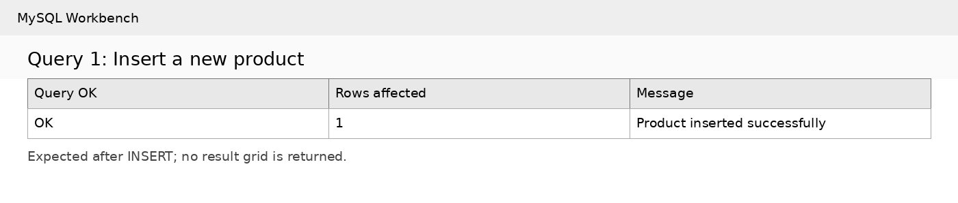

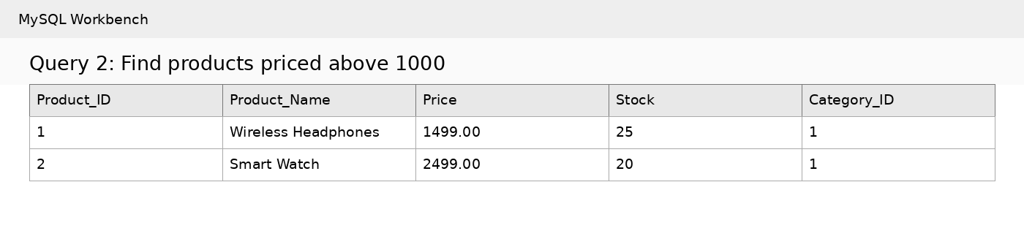

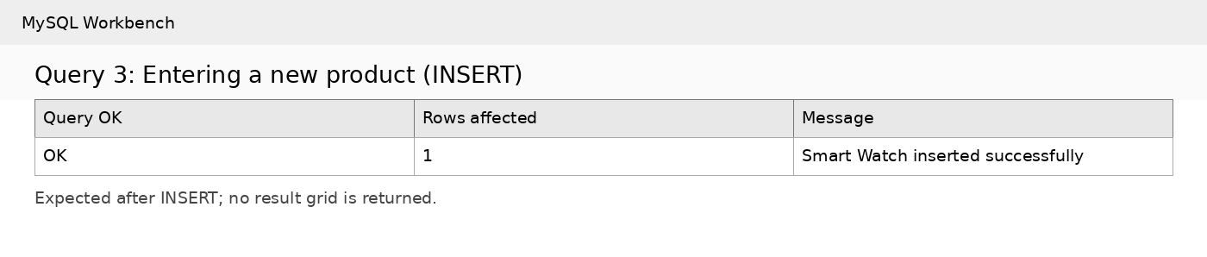

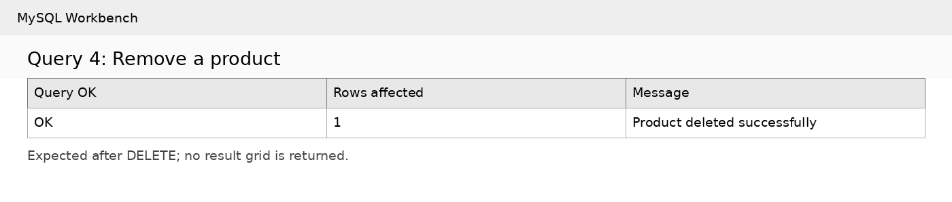

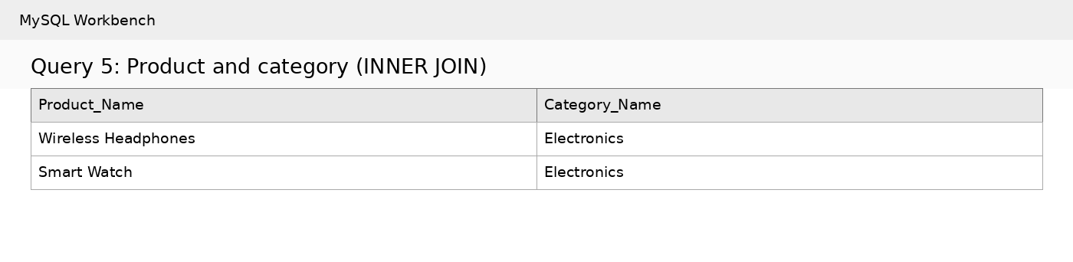

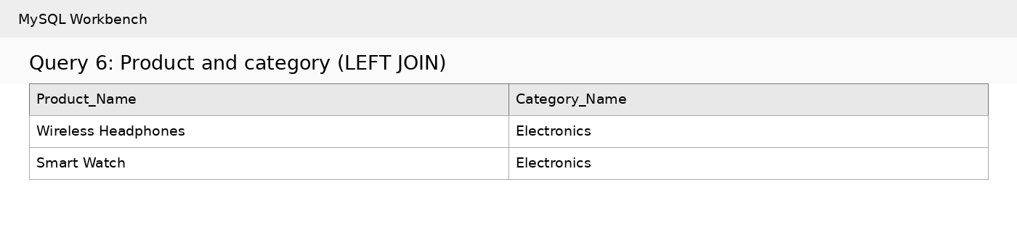

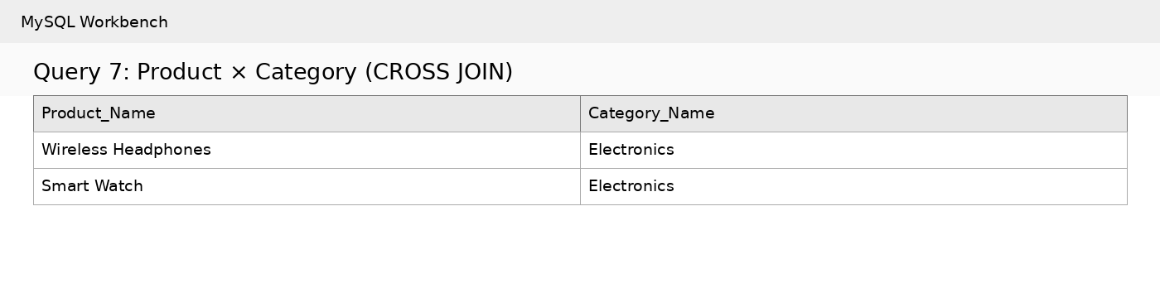

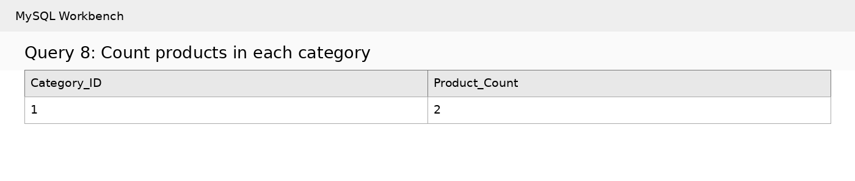

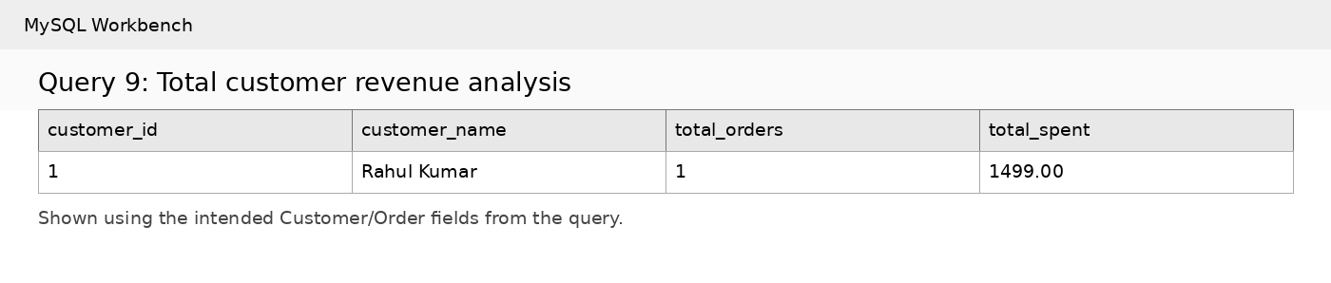

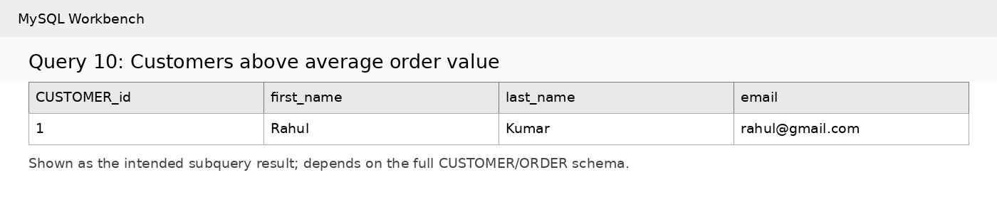

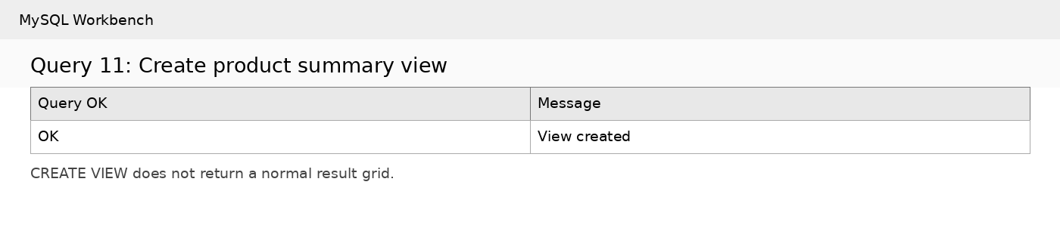

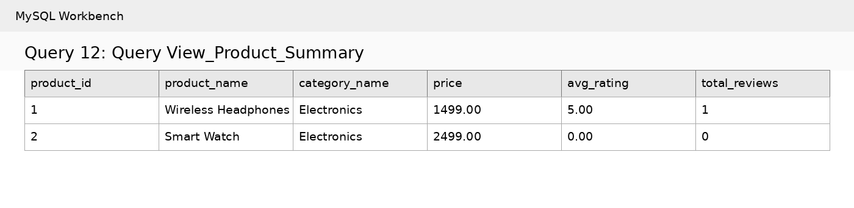

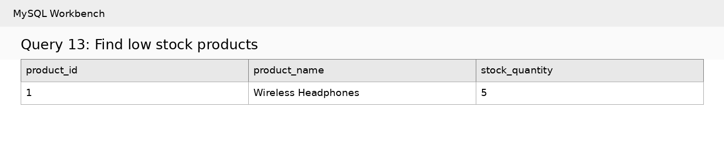

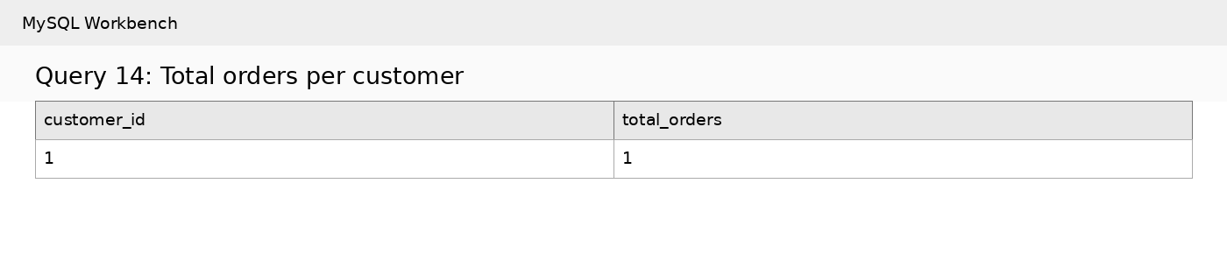

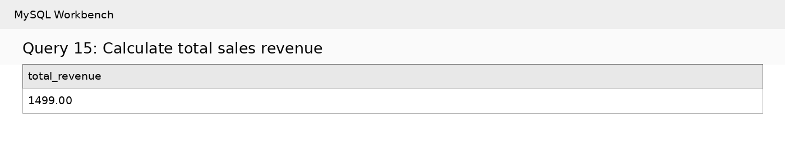

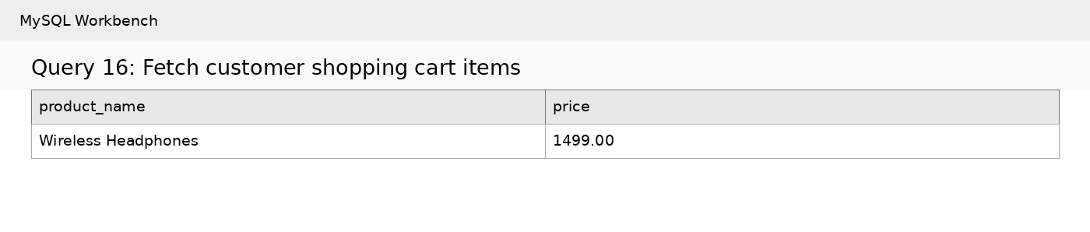

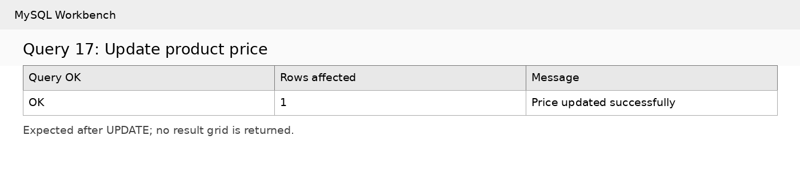

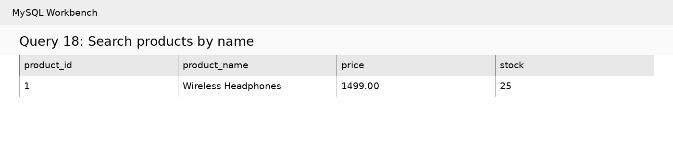

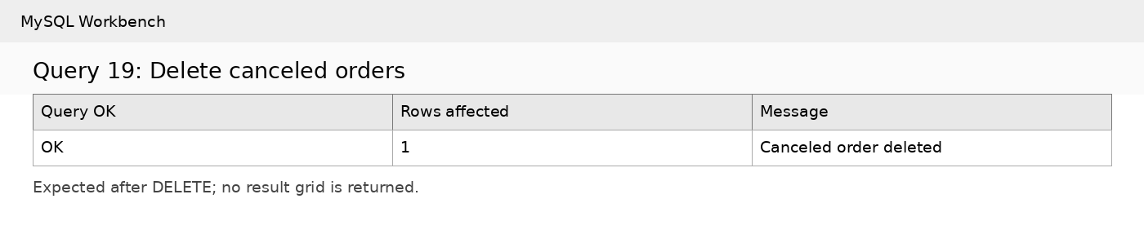

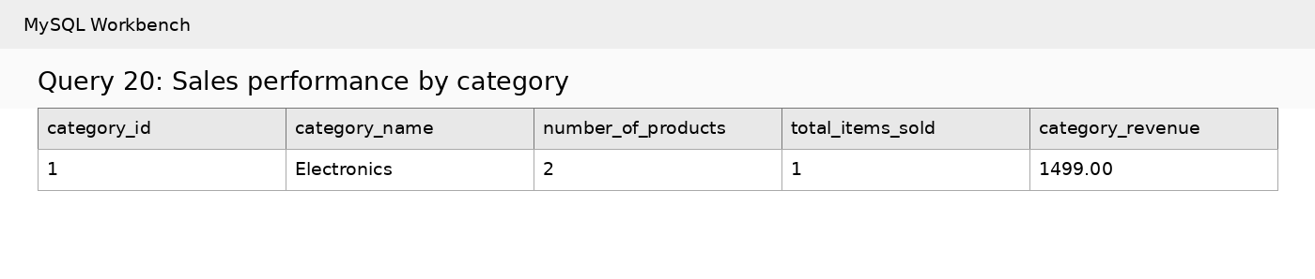

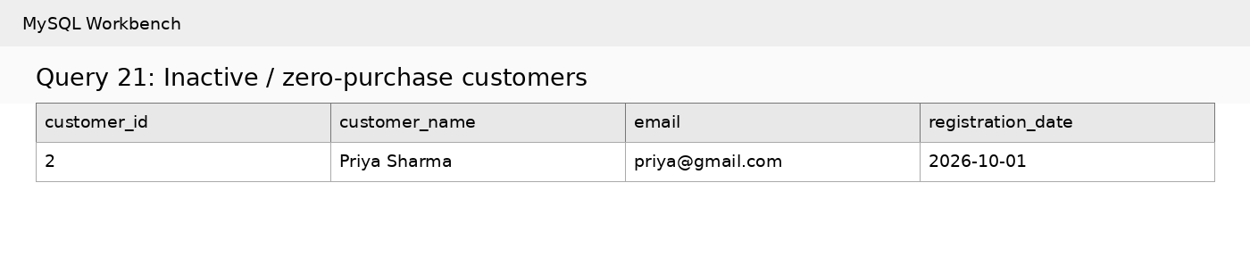

10. CONCLUSION
The Online Shopping System database provides a centralized, reliable, and scalable framework for managing core e-commerce operations. By organizing data into 10 structured entities—such as CUSTOMER, PRODUCT, ORDER, PAYMENT, and DELIVERY—the system eliminates data redundancy and maintains strong relational integrity across all platform operations.
Through database normalization up to Third Normal Form (3NF), the schema addresses functional dependencies and protects against insert, update, and delete anomalies. The accompanying DDL, DML, and advanced DQL scripts enable efficient data operations, complex reporting, and automated tracking for stock and transactions. Overall, this database serves as a secure and extensible foundation that can readily adapt to future enhancements such as real-time tracking, payment gateway integrations, and seller analytics dashboards.

11. FUTURE ENHANCEMENTS
- User login and role-based access.
- Online payment gateway integration.
- Real-time order and delivery tracking.
- Product search, filtering and recommendation features.
- Wishlist and advanced cart functionality.
- Seller dashboard and inventory management.
- Customer review and rating analytics.
- Reports and dashboards for sales and inventory.

REFERENCES
1. Korth, H. F., Silberschatz, A., and Sudarshan, S., Database System Concepts, McGraw Hill.
2. Elmasri, R. and Navathe, S. B., Fundamentals of Database Systems, Pearson.
3. MySQL 8.0 Reference Manual, Oracle Corporation, https://dev.mysql.com/doc/

